AOP using a class and its method in other classes/methods without having to write its code in those classes
Used in logging, security, transactions, and auditing (who did what)
Aspect: module of code for a cross-cutting concern (concern that cuts in many different places; e.g., logging)
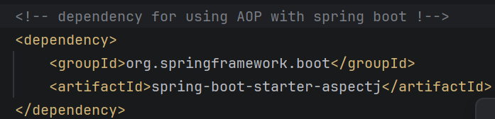
Advice: what action is taken and when it should be applied
@Before -> do aspect before method
@After -> do aspect after method
@Around -> do aspect before and after method
Join point: a possible place to apply the aspect

Pointcut expression (rule) for selecting which join points to apply aspect on
Execution pointcut (match on method name)
Syntax => execution(modifiers? return-type declaring-type? method-name(parameters) throws?)
? optional (don’t have to include)
Modifiers public / private / protected
Declaring-type class / interface that has the method
Return-type data type of returned statement method
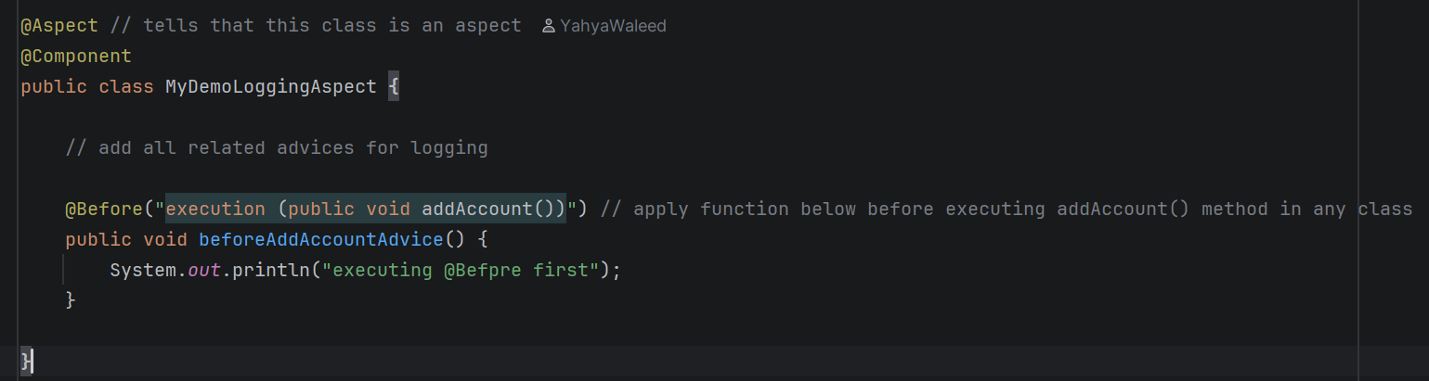
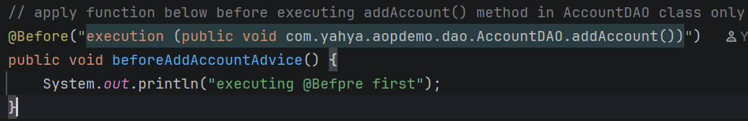
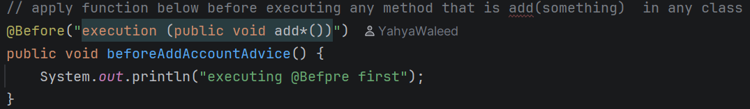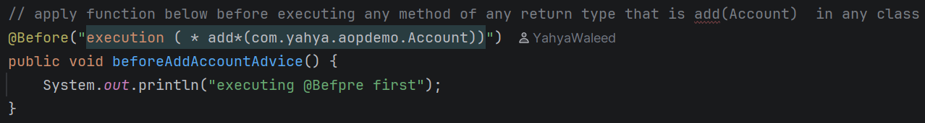
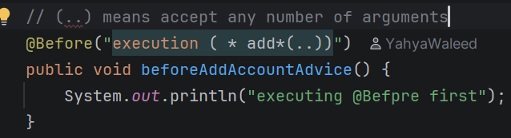
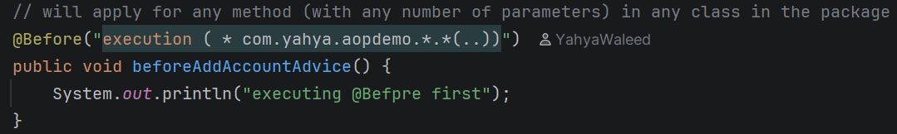

Pointcut Declaration: instead of writing the pointcut expression multiple times, declare it and write it once
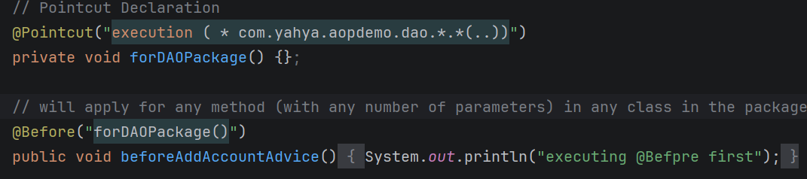
Combining pointcuts:
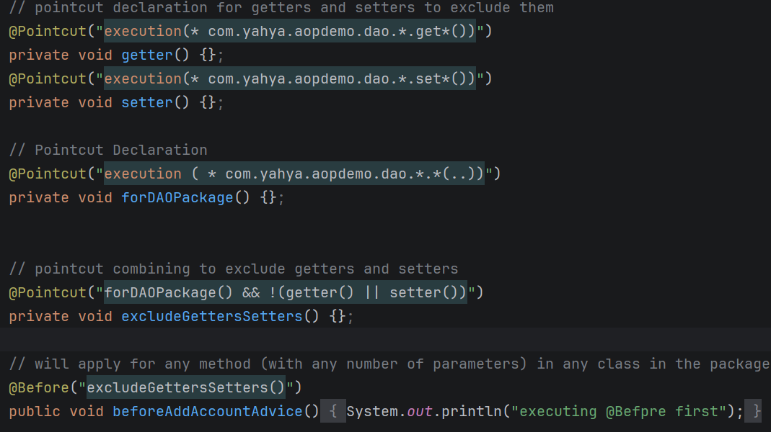

Ordering Aspects:
- Add each aspect in a separate class
- Add declaration in their own class
- Use @Order() before each aspect class
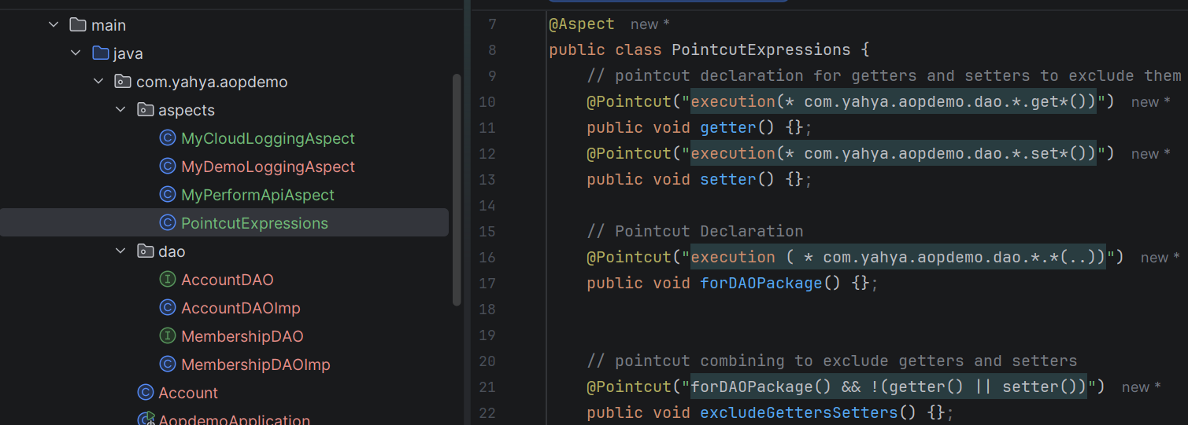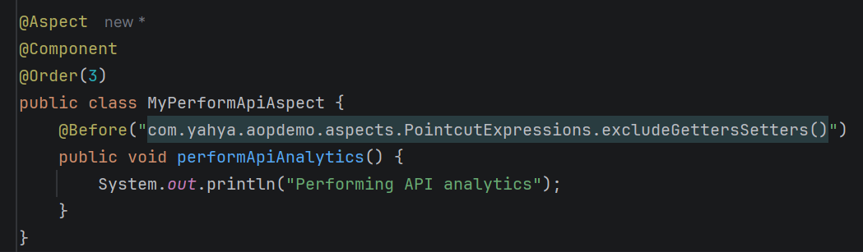

JoinPoint object object containing information about where aspect happened
Method signature = method name + parameter type
Signature.getName()
Signature.getParamaterTypes()
Signature.getReturnTypes()

